EXP NO – 13
MODELING CLOCK-DRIVEN CONCURRENT PROCESSES USING SC_THREAD AND WAIT() IN SYSTEMC

AIM
To model and simulate clock-driven concurrent processes using SC_THREAD and wait() in SystemC, demonstrating the concurrent execution of multiple processes synchronized by a clock signal.

PROGRAM
#include <systemc.h>
SC_MODULE(Example)
{
sc_in<bool> clk;

void process1()
{
while(true)
{
cout<<"Process 1 : "<<sc_time_stamp()<<endl;
wait();
}
}

void process2()
{
while(true)
{
cout<<"Process 2 : "<<sc_time_stamp()<<endl;
wait();
}
}

SC_CTOR(Example)
{
SC_THREAD(process1);
sensitive<<clk.pos();

SC_THREAD(process2);
sensitive<<clk.pos();
}
};

int sc_main(int argc,char* argv[])
{
sc_clock clock("clock",10,SC_NS);

Example ex("Example");

ex.clk(clock);

sc_start(100,SC_NS);

return 0;
}

SIMULATION
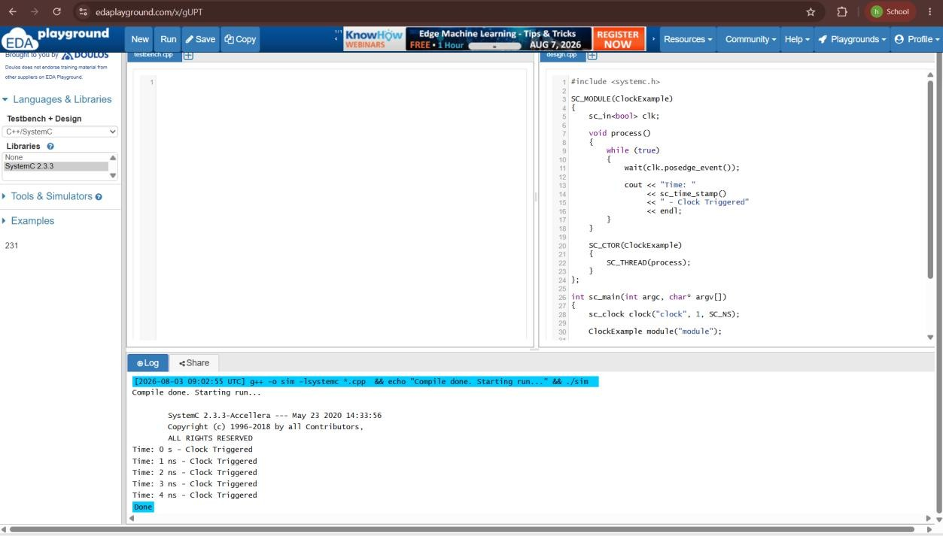

OUTPUT
